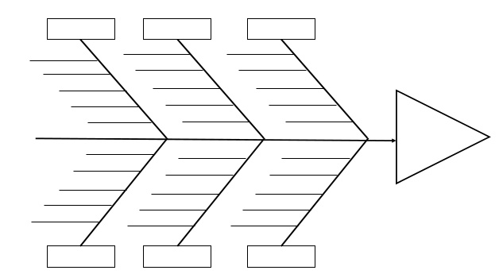

**#3 - INTERNAL CAUSES**

**I HAVE CONTROL OF THESE.**

**EX: IMPLEMENTING AN INSTRUCTIONAL STRATEGY**

**#4 - SMART GOAL**

**TOWARDS IMPROVEMENT**

**#1 - PROBLEM OF PRACTICE**

**CURRENT REALITY**

**#3 - INTERNAL CAUSES**

**I HAVE CONTROL OF THESE.**

**EX: IMPLEMENTING AN INSTRUCTIONAL STRATEGY**

**#2 - EXTERNAL CAUSES**

**I DO *NOT* HAVE CONTROL OF THESE.**

**EX: DISTRICT POLICY.**

**#2 - EXTERNAL CAUSES**

**I DO *NOT* HAVE CONTROL OF THESE.**

**EX: DISTRICT POLICY.**